**CHAPTER 8**

**SCREENSHOTS**

**8.1 Loading Page**

The Figure 8.1 shows the loading page of the application. The system will show this screen when the user starts the application.

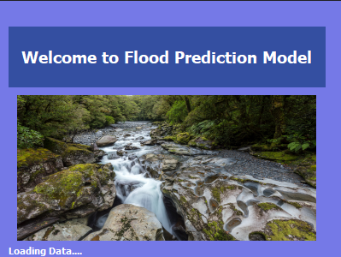

***Figure 8.1:*** *Loading Page*

**8.2 Home Page**

The figure 8.2 shows the home page of the application. This is where the user will see details of the current weather of his/her location. The user will also select the state and the month for the flood prediction.

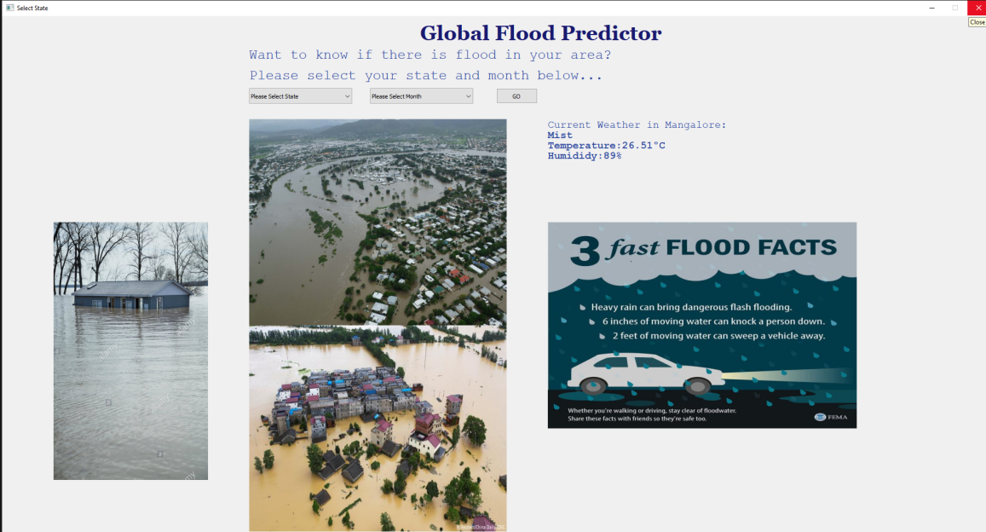

***Figure 8.2:*** *Home Page*

**8.3 Select State Error**

The figure 8.3 shows the error when user does not select a state and clicks Go. This is an expected error and is handled accordingly.

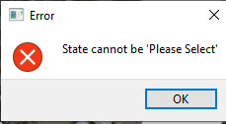

***Figure 8.3:*** *State not selected error*

**8.4 Select Month Error**

The figure 8.4 shows the error when user does not select a month and clicks Go. This is an expected error and is handled accordingly.

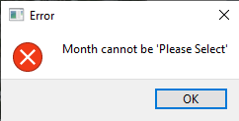

***Figure 8.4:*** *Month not selected error*

**8.5 Graphical Information**

The figure 8.5 shows the rainfall information in a graphical form. In the x-axis the month is shown and y-axis represents the amount of rainfall in millimetres.

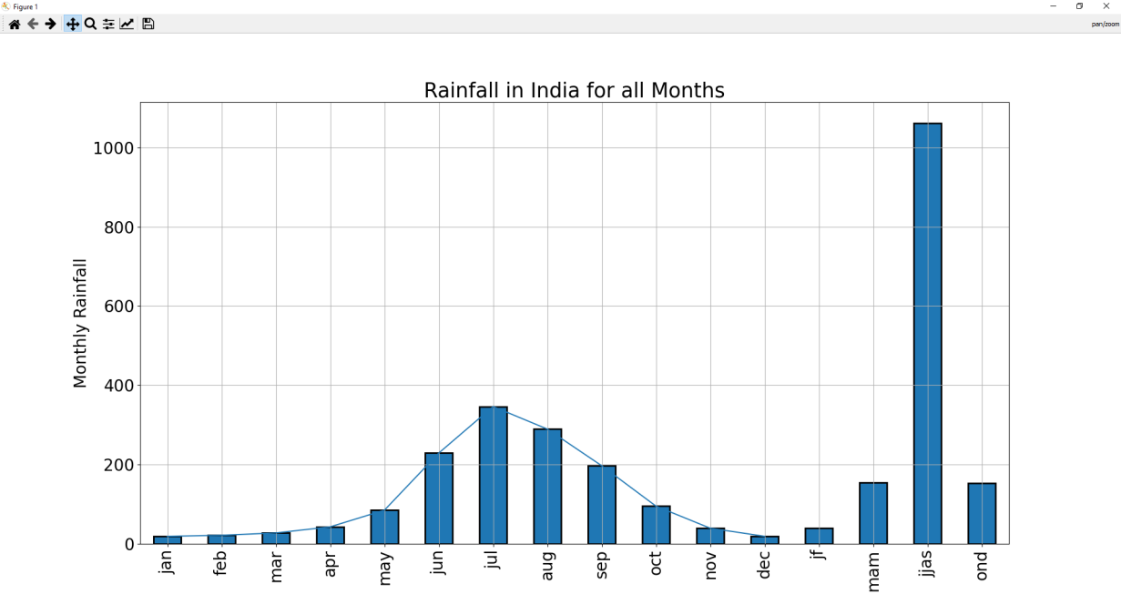

***Figure 8.5:*** *Graphical Information about Rainfall*

**8.6 Final Output**

The figure 8.6 shows the final output of the application where the prediction of rainfall is shown along with the accuracy of the prediction using different algorithms.

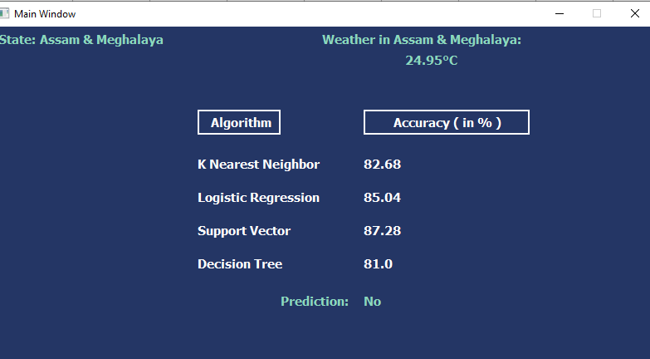

***Figure 8.6:*** *Final Output*